Department of Anglo-Saxon,  Norse and Celtic | 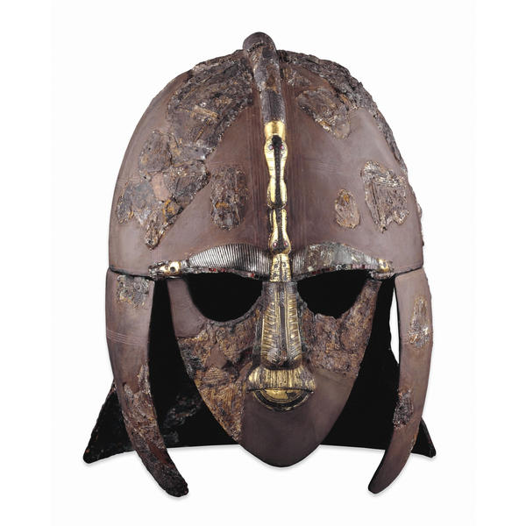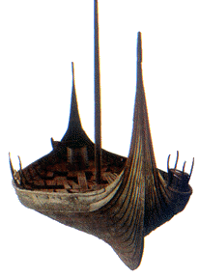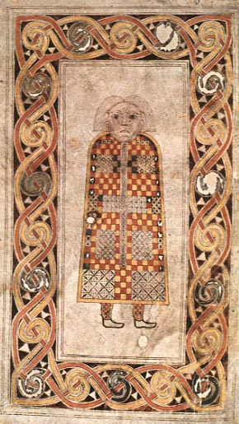
Annual ASNC Open Day
Wednesday 26 June 2024

The Anglo-Saxon, Norse and Celtic Tripos is concerned with the history, languages, literature and material culture of the British Isles, Ireland and Scandinavia in the early medieval period. It is a wide-ranging course, which is likely to appeal to anyone with an interest in medieval history, languages, and literature. Graduates in ASNC gain employment in a wide variety of fields; the degree also provides a stage in the training of potential scholars in the field.

If you are interested in this Tripos, and are considering applying for a place in a Cambridge college from October 2024, you are warmly invited to an informal Open Day at the Faculty of English Building, Sidgwick Site, Cambridge, on Wednesday 26 June 2024. The teaching staff of the Department of Anglo-Saxon, Norse and Celtic will describe the courses they provide, the kinds of materials studied, the range of choices the Tripos offers, and the kinds of employment our graduates move into. There will be opportunities to put questions and to ask advice about application procedures for both prospective students and accompanying parents; students currently on the course will be available for informal consultation. A visit to a College Library to view Anglo-Saxon and other medieval manuscripts will follow the presentations.

The event will begin at 12.15pm. On arrival, those attending should gather in the Social Space on the Ground Floor of the Faculty of English building. There will be no charge for attendance, and a buffet lunch will be provided. The presentations will end by 4.00pm and the library visit by 5.00pm. We regret that it is impossible for us to provide overnight accommodation. Details of accommodation in Cambridge are available from the Tourist Information Centre: www.visitcambridge.org.

Anyone wishing to attend the Open Day should complete the below form and email it to events@english.cam.ac.uk by Monday 10 June 2024.

For further details of the Department, please visit our website: www.asnc.cam.ac.uk
For further details on what we do with your personal information go to https://www.information-compliance.admin.cam.ac.uk/data-protection/general-data
………………………………………………………………………………………………………………………………………
To: The Events Secretary, Faculty of English, 9 West Road, Cambridge, CB3 9DP.
Booking Form for the ASNC Open Day on Wednesday 26 June 2024

Name(s):
Email address:
School:
Parents are welcome (but not expected!) to attend.
Number of people attending:
Number of people wishing to take the tour of the College Library:
Number of people for lunch:
Any special dietary requirements:

